**ARYAMAN MISHRA**

**19BCE1027**

SOFTWARE USED:LTSPICE

**Task 1: Implementation of Inverter**

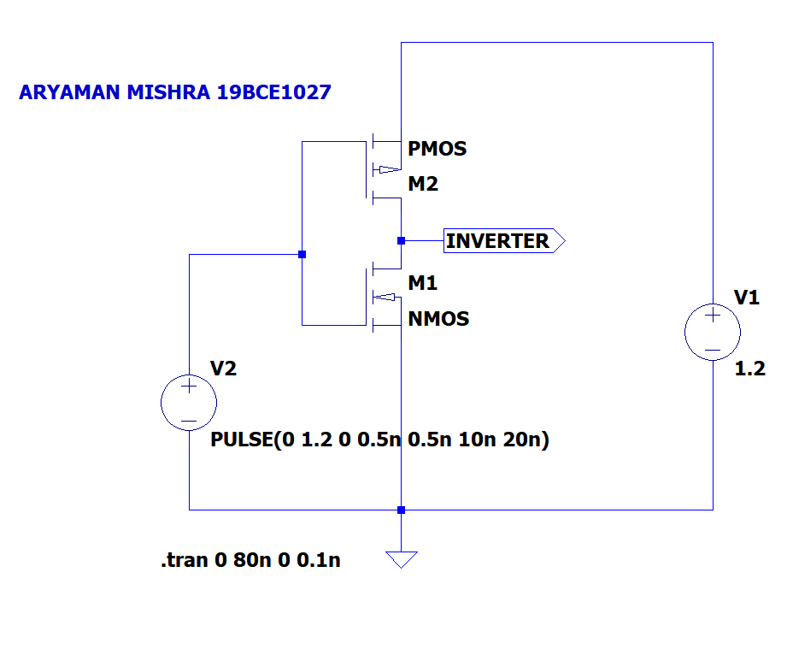

Results:

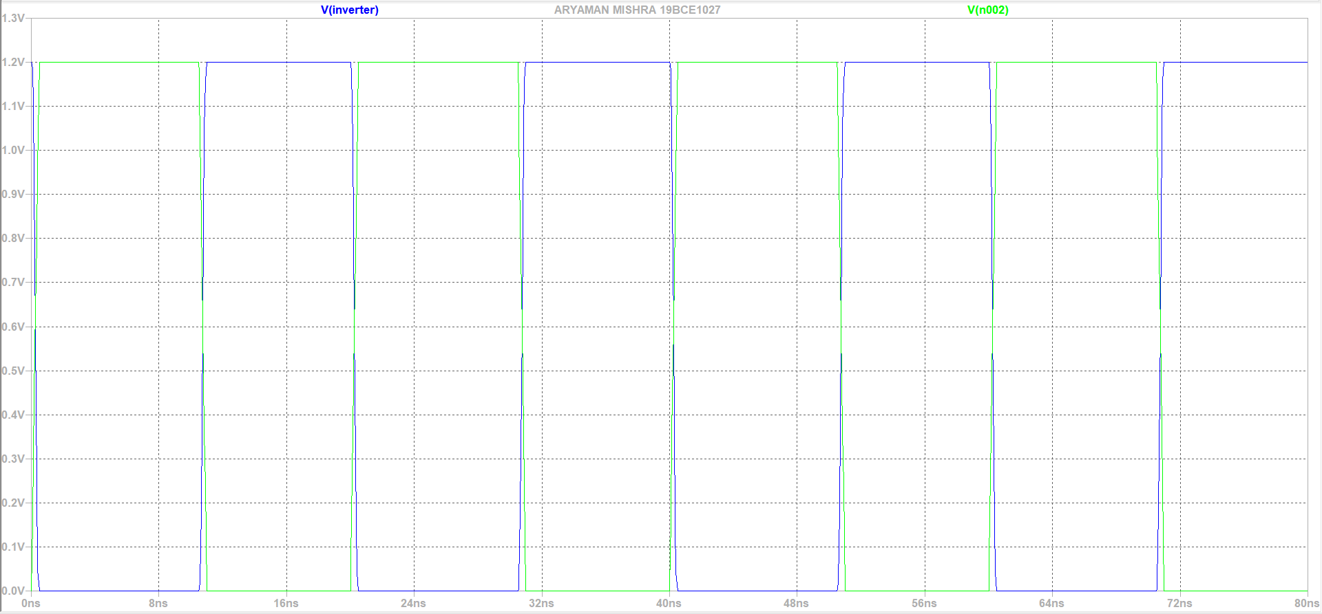

**Truth Table:**

|  |  |
| --- | --- |
| **Vin** | **Vout** |
| 1 | 0 |
| 0 | 1 |

**Conclusion:**

From above graph we can observe that output is high when input is low and low when input is high. Thus, an inverter is implemented using PMOS and NMOS.

**Task 2: Implementation of Inverter using CMOS**

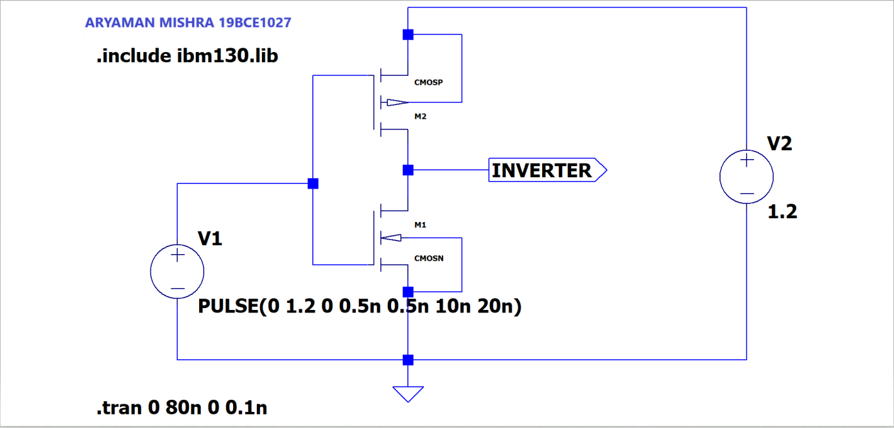

**Output:**

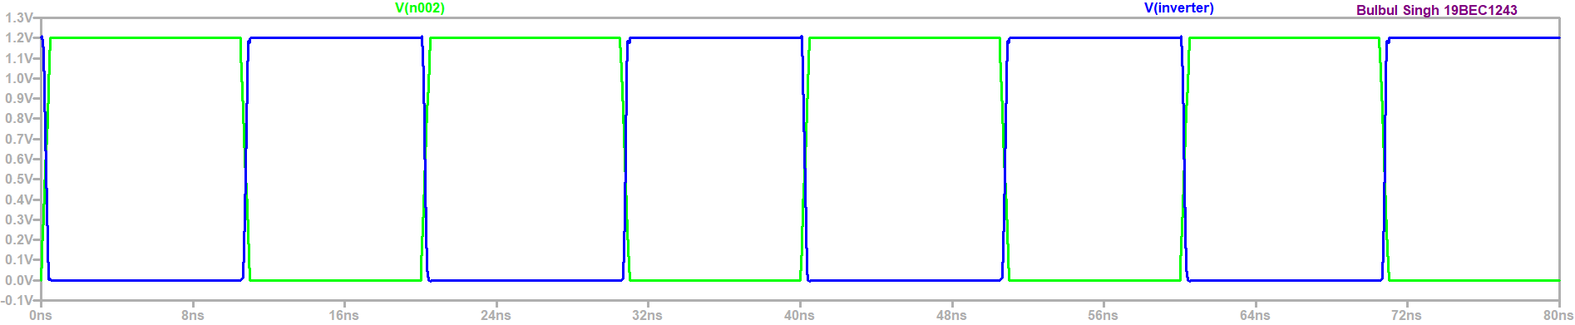

**Truth Table:**

|  |  |
| --- | --- |
| **Vin** | **Vout** |
| 1 | 0 |
| 0 | 1 |

**Conclusion:**

From above graph we can observe that output is high when input is low and low when input is high. Thus, an inverter is implemented using CMOSN AND CMOSP.

**Task 3: To study transition characteristics of Invertor using 130nm technology**

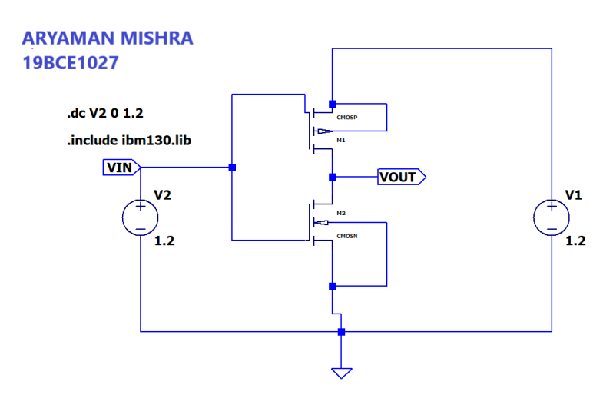

**Output:**

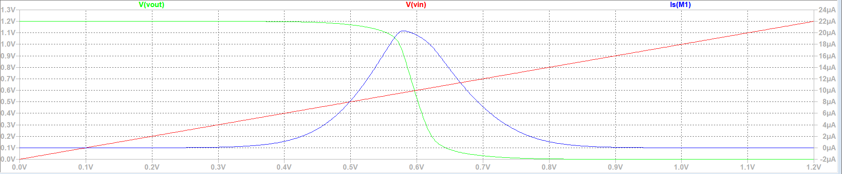

**Conclusion:**

From above graph we can observe that transition region is from 0.3 V to 0.9 V and also, Vin and Vout do not intercept at 0.6V point.

**Task 4: To study transition characteristics of Invertor using 130nm technology: Symmetric**

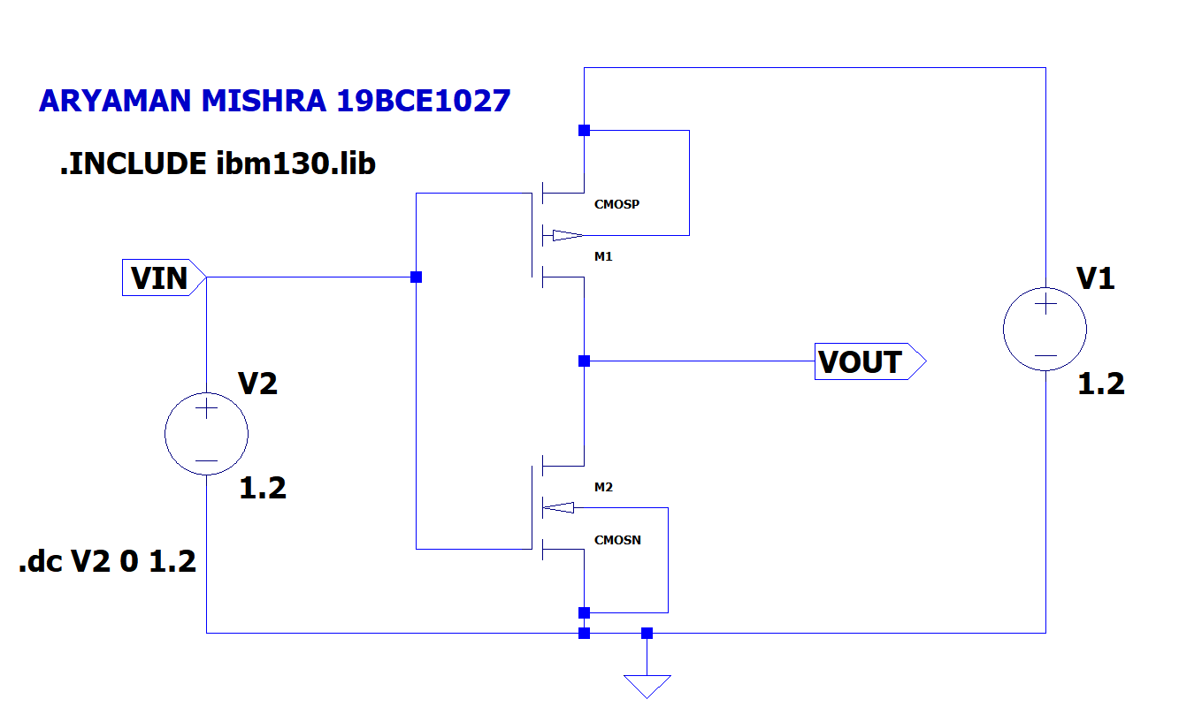

Results:



**Conclusion:**

From above graph we can observe that transition region is from 0.3V to 0.9 V and Vin and Vout intercept at 0.6V point because of Symmetric properties.

**Task 5: To implement NAND gate using CMOS**

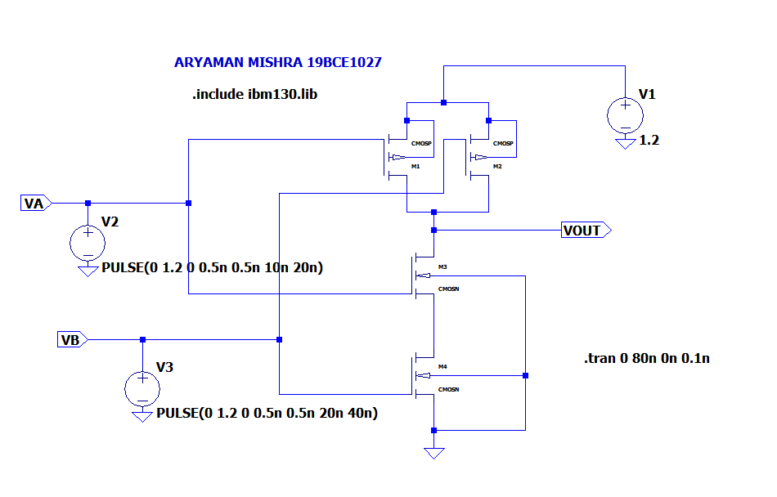

Results:

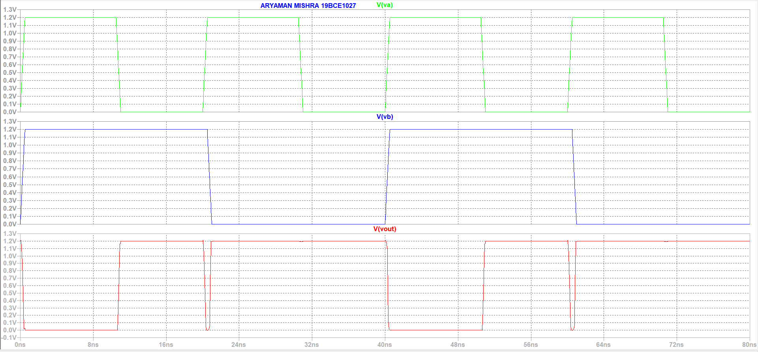 **Truth Table:**

|  |  |  |
| --- | --- | --- |
| **V_A** | **V_B** | **V_out** |
| 0 | 0 | 1 |
| 0 | 1 | 1 |
| 1 | 0 | 1 |
| 1 | 1 | 0 |

**Conclusion:**

From the above graph we can observe that when both inputs are high, output is low while in all other cases it is high thus, it satisfies the truth table.

**Task 6: To implement NOR gate using CMOS**

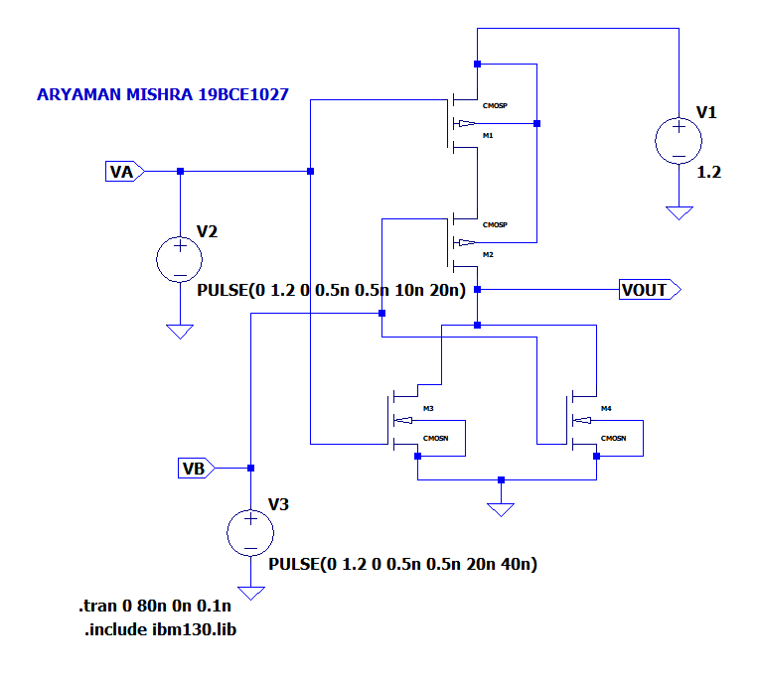

Results:

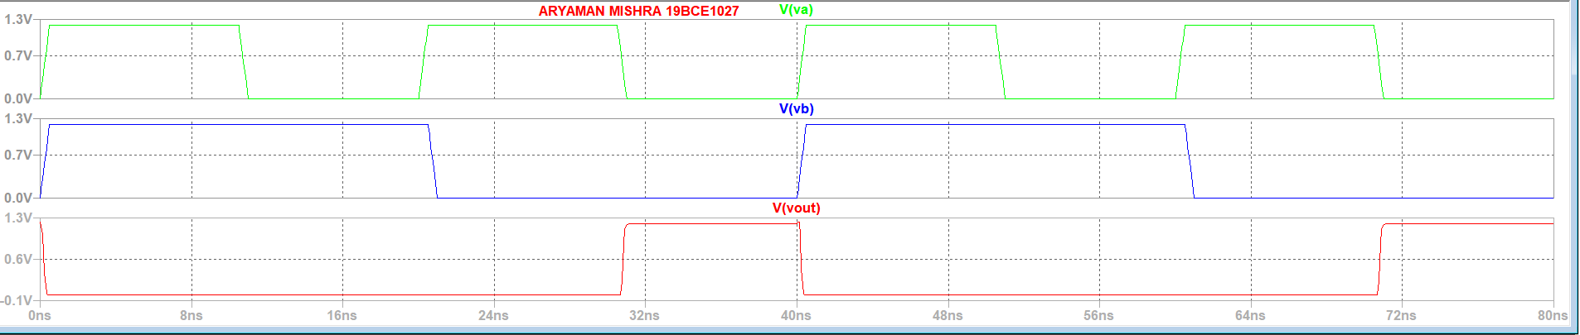

**Truth Table:**

|  |  |  |
| --- | --- | --- |
| **V_A** | **V_B** | **V_out** |
| 0 | 0 | 1 |
| 0 | 1 | 0 |
| 1 | 0 | 0 |
| 1 | 1 | 0 |

**Conclusion:**

From the above graph we can observe that when both inputs are low, output is high while in all other cases it is low thus, it satisfies the truth table.